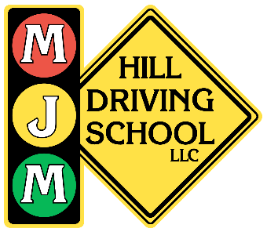
MJM HILL DRIVING SCHOOL
Parent & Student Online Portal

Beginner's Guide
Step-by-step instructions for using the MJM Hill online platform —
from logging in to scheduling lessons, managing your account, and more.
Phone: 608-328-2090 | Email: info@mjmhill.com | Website: www.mjmhilldrivingschool.com

Welcome, Parents and Students! This guide was written especially for you — no technical experience needed. Just follow each step in order and you'll be set up and scheduling lessons in no time. If you ever get stuck, MJM Hill's team is always happy to help at 608-328-2090 or info@mjmhill.com.

Table of Contents
Section | Topic
Section 1 | How to Log In
Section 2 | Your Dashboard — Home Base
Section 3 | My Account — Your Profile
Section 4 | Scheduling a Driving Session (My Schedule)
Section 5 | My Services — Viewing & Adding Packages
Section 6 | My Files — Accessing Your Documents
Section 7 | Quick Tips, Common Issues & Contact Info

Section 1: How to Log In

Getting started is simple. Follow these steps the first time you log in. You can access the portal from any device — a phone, tablet, or computer — using any modern web browser.
Step 1: Go to the MJM Hill Website
Open any web browser (Chrome, Firefox, Edge, or Safari) on your phone or computer and go to:
www.mjmhilldrivingschool.com
Once on the homepage, look for the large red "Account Login" button in the center of the page.
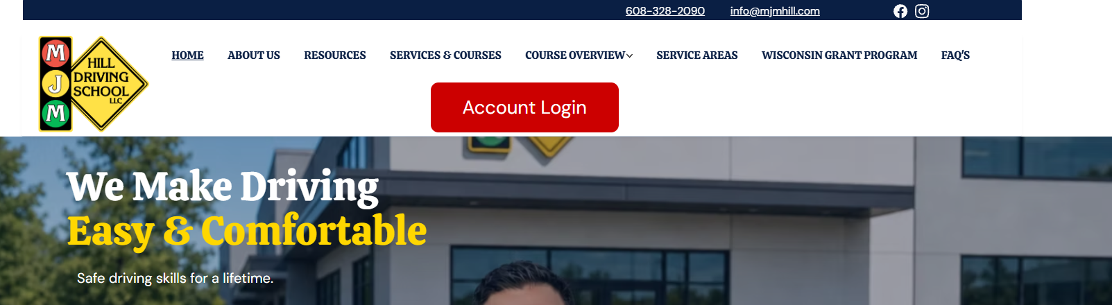
The MJM Hill homepage. Look for the large red "Account Login" button and click it to access the portal.
Step 2: Enter Your Login Information
You will be taken to the login page. Enter the following information:
- Your email address (the one you used when you registered)
- Your password
💡 First Time Logging In? Check your email inbox for a welcome message from MJM Hill — it will contain your login credentials and account details.

💡 Forgot Your Password? Click the "Forgot Password?" link on the login page. Enter your email address and check your inbox. Check your spam/junk folder if you don't see it.
- Click Submit

Section 2: Your Dashboard

Once you log in, you'll land on your Dashboard. Think of this as your home base — it shows you everything important at a glance. You'll visit this page every time you log in.
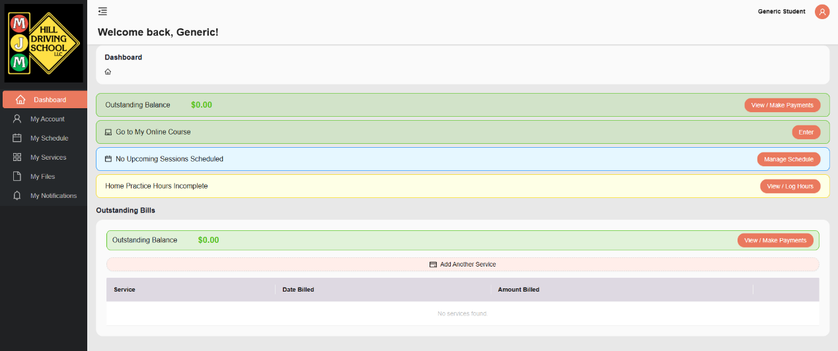
The Dashboard view after logging in. You can see your balance, course access, upcoming sessions, and practice hours all in one place.
Dashboard Item | What It Means
Outstanding Balance | Any amount currently owed. Green means $0.00 (all paid up!). Click "View / Make Payments" to pay.
Go to My Online Course | Click "Enter" to access your student's online classroom course materials.
Upcoming Sessions | Shows the next scheduled Behind the Wheel (BTW) session. Click "Manage Schedule" to add one.
Home Practice Hours Incomplete | Tracks required home driving practice hours. Click "View / Log Hours" to log them.
Outstanding Bills | Lists any services billed and the amounts still owed.
Add Another Service | Click this pink bar to add extra lessons or packages to your account at any time.

Section 3: My Account — Your Profile

The My Account page is where you can view and manage your student's personal information, permit details, and account security settings. It's important to keep this information accurate and up to date.
To get there: Click "My Account" on the left sidebar menu.
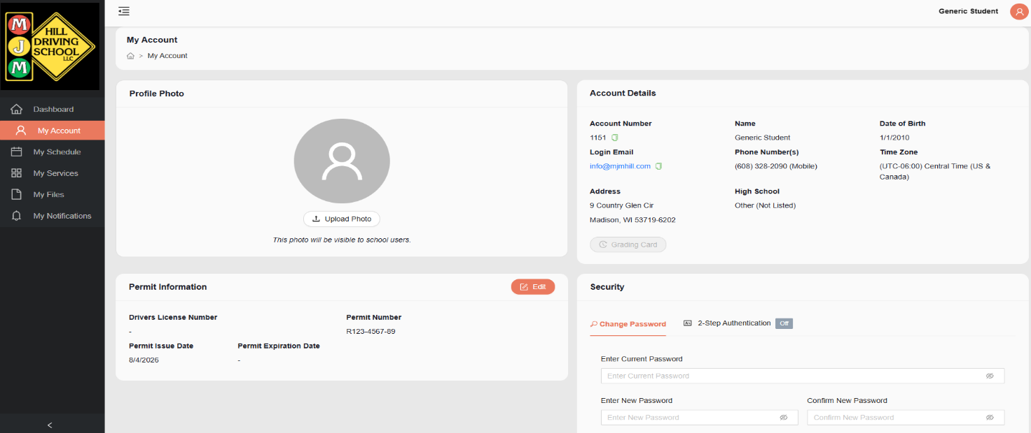
The My Account page showing profile photo, account details, permit information, and security settings.
What you'll find here:
- Profile Photo — Upload a photo of your student (visible to school staff). Click "Upload Photo."
- Account Details — Displays the student's name, account number, date of birth, login email, phone number, address, high school, and time zone.
- Permit Information — Shows your student's Driver's License Number, Permit Number, Permit Issue Date, and Permit Expiration Date. Click the orange "Edit" button to update this information.
- Security — Change your password here. You can also enable 2-Step Authentication for extra account security.

💡 Important: Make sure your student's permit number and expiration date are entered and kept up to date. This information is required before you can schedule Behind the Wheel lessons. If the permit fields are blank, you won't be able to book a session.

Section 4: Scheduling a Driving Session (My Schedule)

This is where Students can book their Behind the Wheel (BTW) driving sessions and Observation (OBS) sessions. *Remember- ONLY Student Accounts will be able to book Sessions*
To get there: Click "My Schedule" in the left sidebar, then click "Manage BTW Schedule."
Step 1: Select Your School Location
You will see a grid of school location cards. Each card shows:
- How many BTW+OBS, BTW Only, and OBS Only spots are available
- A "View Available Sessions" button — Orange means spots are available; gray means no spots- it will also tell you “0 Spots” which is saying how many spots are open.
- A "Join Waitlist" button for any location is available. Click this and add yourself to a Waitlist if a date and time work for you. If a spot opens up due to a change or cancellation- you will be notified first, and added to the slot.
Click "View Available Sessions" on the school location closest to your student.
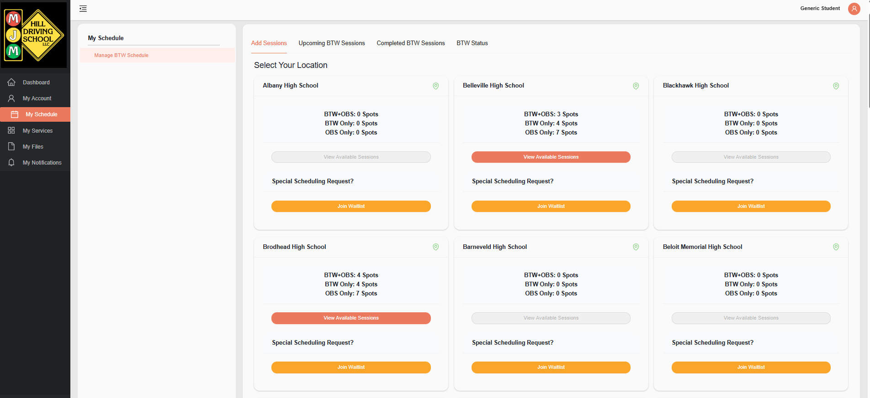
Choose your student's school location. Orange "View Available Sessions" buttons mean spots are open.

Step 2: Choose Your Session Type
A pop-up window called "Add Scheduled Session" will appear. Use the dropdown menus to filter your options:
- Location (e.g., Belleville High School)
- Session Type — Choose from:
  - BTW — Behind the Wheel (driving only)
  - OBS — Observation only (student watches from the back seat)
  - BTW + OBS — Behind the Wheel AND Observation combined (most common choice)
- Time of Day — Morning, Afternoon, or Evening
- This online scheduler gives the students the freedom to choose any combination of session that fits within their schedule. If they only have an hour due to a lunch or study hall- they can either drive or do an observation only to catch up.
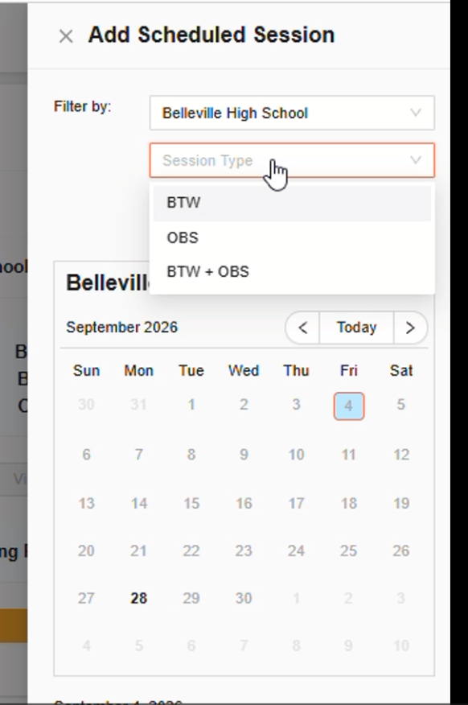

Step 3: Pick a Date on the Calendar
After selecting your filters, a calendar will appear showing available dates. Click on a date that works for your student. The session details will appear below the calendar, showing:
- Session type (e.g., Behind the Wheel and Observation)
- Date and time (e.g., September 28, 2026, 12:00 PM – 2:00 PM)
- Location (e.g., Belleville High School)
Read the Important Notes carefully — they tell you exactly where to drop off your student (outside the main office entrance, not the high school entrance).
Click "OK" to confirm your booking.
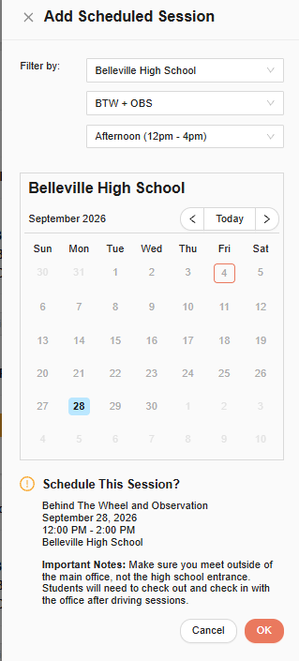
The session confirmation popup. Review the date, time, and location details carefully before clicking "OK."

After You Book: You will receive a confirmation email at your registered email address. Save this email; it contains the session time, location, and important drop-off instructions.

What If There Are No Available Spots? — Join the Waitlist
If your preferred school location shows 0 spots available, don't worry! You can join the Waitlist and MJM Hill will contact you when new sessions open up.
How to Join the Waitlist:
- Click the yellow "Join Waitlist" button on the school location card.
- A "Join Waitlist" form will appear.
- Your preferred location will already be pre-selected (e.g., New Glarus High School).
- Use the day-of-week dropdowns (Monday through Sunday) to indicate which days work best.
- Add any notes or special requests in the "Notes/Comments" box.
- Click the orange "Save" button.
MJM Hill will reach out to you when a spot that matches your preferences becomes available.
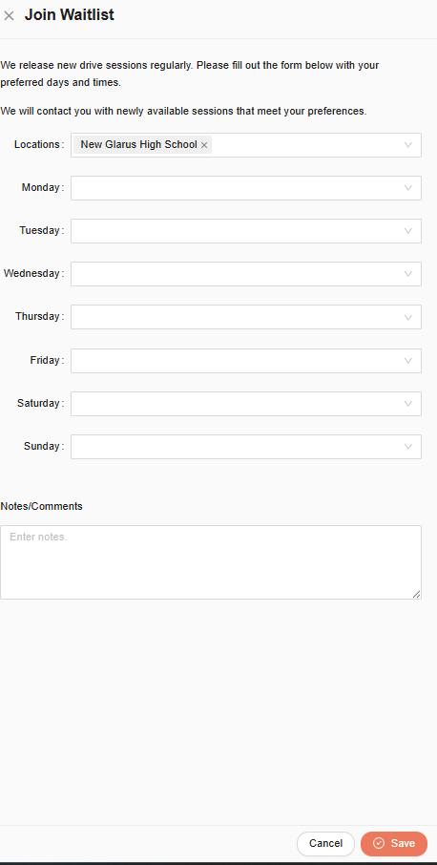
The Join Waitlist form. Select your preferred days and add any notes, then click "Save."

Section 5: My Services — Viewing & Adding Packages

My Services shows you the driving packages and services that are currently enrolled for your student, as well as the option to add more services at any time.
To get there: Click "My Services" in the left sidebar menu.
What you'll see on this page:
- Outstanding Balance — Any amount still owed (green = $0.00, all paid)
- Add Another Service — Click this pink button to add a new package
- A list of enrolled services with the Date Billed and Amount Billed
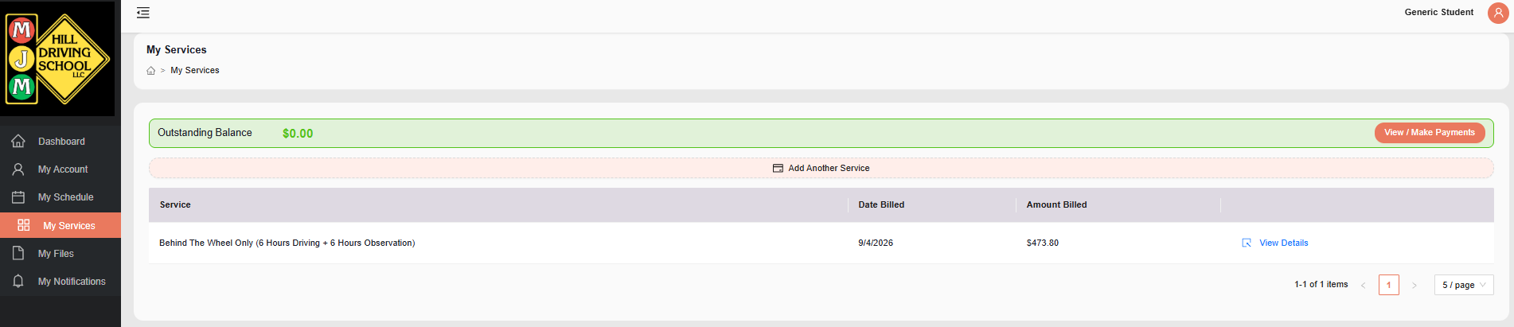
The My Services page showing your student's enrolled package, billing date, and amount.

How to Add Another Service
Step 1: Click "Add Another Service"
From the Dashboard or My Services page, click the pink "Add Another Service" bar. A pop-up window will appear titled "Add Another Service."

Step 2: Choose a Service Type
Under "Class/Service Type," click the search/dropdown box and choose from the available options:
- Behind The Wheel Only
- In Person Classroom
- Hybrid Classroom
- Online Classroom Only
- Package
- Behind The Wheel + Observation
- Road Test
Click the service type you want to add.
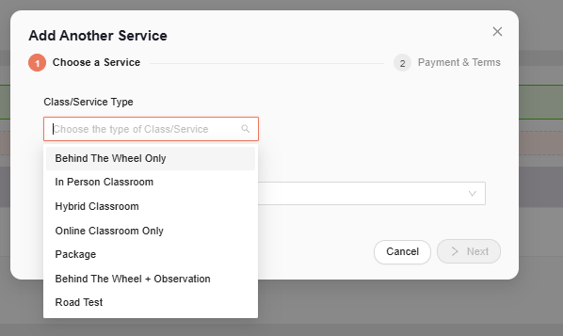
The Add Another Service pop-up. Click the dropdown to choose from available service types.

Step 3: Review Payment & Complete Purchase
After selecting your service, click "Next." You will move to Step 2: Payment & Terms.
On this screen you will see:
- Promo Code field — Enter a code here if you have one, then click "Apply"
- Order Summary — Shows the service name, processing fee, and total amount due
- Payment Method — Select how you'd like to pay
- Terms of Service — Check the box to agree before completing your purchase
Once everything looks correct, click "Complete Purchase."
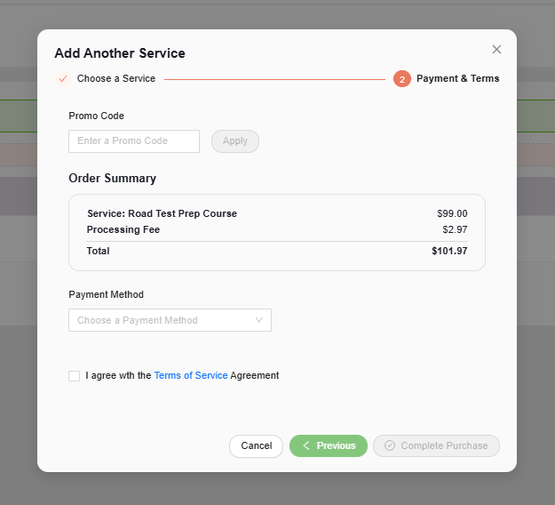
The Payment & Terms screen. Review your order summary, select a payment method, agree to terms, then click "Complete Purchase."

Section 6: My Files — Accessing Your Documents

The My Files section stores all important documents related to your student's enrollment — forms, guides, agreements, and state-required paperwork. You can both download documents from MJM Hill and upload documents of your own here.
To get there: Click "My Files" in the left sidebar menu.
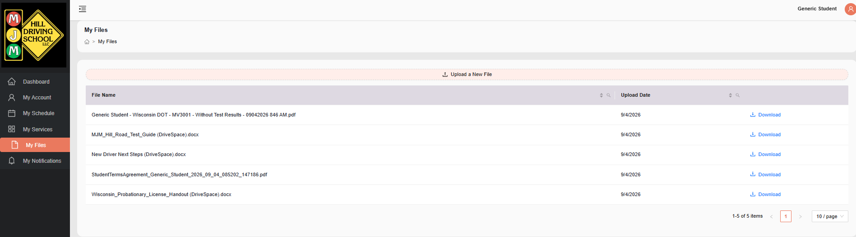
The My Files page. All of your important documents are listed here with download links.

What you might find in My Files:

File Name | What It Is
Wisconsin DOT – Signed MV3001 | State DMV form needed for written tests/Permit— keep this for your records after course completion
MJM Hill Road Test Guide | Instructions and helpful tips for the Wisconsin road test
New Driver Next Steps | A checklist of what to do after completing the Education course
Student Terms Agreement | Your signed enrollment agreement with MJM Hill
Wisconsin Probationary License Handout | Information about Wisconsin's probationary license rules for new drivers

To Download a File
- Find the file name in the list on the My Files page.
- Click the blue "Download" link on the right side of the file name.
- The file will save to your computer or phone's Downloads folder automatically.

To Upload a Document
- Click the "Upload a New File" button at the top of the page.
- Select the file from your device (photo, PDF, etc.).
- Click "Submit."

Important Reminder: If your student has received their Wisconsin learner's permit, make sure the permit information is entered in My Account → Permit Information as soon as possible. This is required before you can schedule any Behind the Wheel sessions.

Section 7: Quick Tips & Reminders

Use this page as a handy reference checklist. Keep it somewhere easy to find — on the fridge, in your car, or saved on your phone!

✓ | Tip
✓ | Log in weekly to check for upcoming sessions, new files, and any outstanding balance.
✓ | Keep permit info updated in My Account → Permit Information. Make sure the permit number and expiration date are always current.
✓ | Book sessions early — spots fill up fast! If your preferred school is full, join the Waitlist right away.
✓ | Read the Important Notes every time you schedule a session – if there is a note on where to meet or anything a student or parent needs to know, it’ll be upon confirmation of a location
✓ | Download your files after each major milestone (enrollment, road test, completion) and save them somewhere safe.
✓ | Check your email after every action (booking, payment, upload) — MJM Hill sends confirmation emails for everything.
✓ | Use the correct email — your login email is the one you registered with. If you're unsure, check your welcome email from MJM Hill.

Common Issues & Solutions

Problem | Solution
Can't log in | Double-check your email and password. Use "Forgot Password?" to reset. Check your spam folder for the reset email.
No available session spots | Join the Waitlist — MJM Hill will notify you when a spot opens at your preferred location.
Session type dropdown is grayed out | A particular type may not be available. Such as “Drive Only” or “Observation Only”
Payment didn't go through | Try a different browser (Chrome or Firefox work best) or a different payment method. Contact MJM Hill if it continues.
Can't find a document in My Files | Contact MJM Hill directly — the document may not have been uploaded yet or may be pending review.
Not receiving confirmation emails | Check your spam/junk folder. Add the sender to your email contacts so messages aren't filtered.
Portal not loading correctly | Clear your browser cache or try using Chrome or Firefox. Avoid Internet Explorer.
Permit info won't save | Make sure all required fields are filled in before clicking "Edit" → "Save." The permit number and issue date are both required.

Concerns or Issues

At MJM Hill Driving School, we hold ourselves — and every instructor who works with your children — to very high standards. If your child ever has an experience they’d like to share — whether something that made them feel especially supported, or simply a preference for working with (or not working with) a particular instructor — we encourage you to reach out to us directly. Hearing from families helps us understand what’s working well and where we can adjust to ensure every student feels comfortable, confident, and safe throughout their lessons. You are always welcome to contact ownership, and any call or email will remain confidential. We will never share your name or your child’s name with an instructor, and we will take thoughtful, appropriate steps to support your family and uphold the standards we set for our program.

Kelly Hill – Owner- kelly@mjmhill.com

Josh Richards – Director of Operations - jtrichards@mjmhill.com

